
_{How is my information used?}
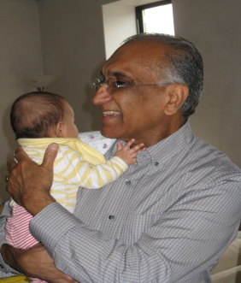
We asked about childcare arrangements in the family home.
The research
Charities Age UK and Grandparents Plus used the data to reveal the important role that grandparents play in supporting parents with childcare.

What the research found
- Half of all mothers rely on grandparents to provide childcare when they return to work after maternity leave

- 63% of all grandparents with a grandchild under 16 look after their grandchildren.

- 19% of grandmothers provide at least 10 hours of childcare a week.

Newspaper headlines
- The babysitting grandparents who save families £7billion a year: Study shows older generation cares for 1.6million UK children
Daily Mail 30th May 2013

- Childcare: Are grandparents entitled to flexible hours? BBC News 30th May 2013

- 'Hidden army' of grandparents helping families priced out of childcare
Guardian 8th July 2014

Questions this raises for policy makers
- Older people work for longer now and cannot look after children as often.

- Pension age is rising – what impact will this have?

- Would cheaper childcare help?

